**LAB Logbook**

**LAB 1:**

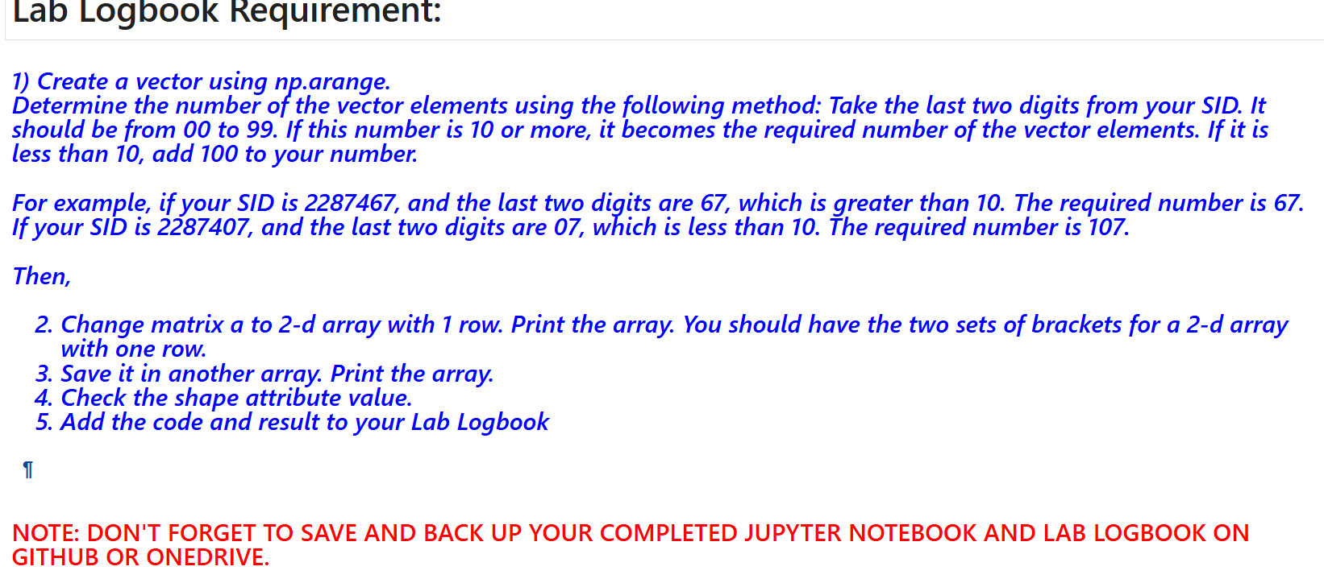

Lab 1

[***¶***](http://localhost:8888/notebooks/week1-NumPy_ML-in-Finance_Final-1.ipynb#1)-Create-a-vector-using-np.arange.Determine-the-number-of-the-vector-elements-using-the-following-method:-Take-the-last-two-digits-from-your-SID.-It-should-be-from-00-to-99.-If-this-number-is-10-or-more,-it-becomes-the-required-number-of-the-vector-elements.-If-it-is-less-than-10,-add-100-to-your-number.For-example,-if-your-SID-is-2287467,-and-the-last-two-digits-are-67,-which-is-greater-than-10.-The-required-number-is-67.-If-your-SID-is-2287407,-and-the-last-two-digits-are-07,-which-is-less-than-10.-The-required-number-is-107.Then,-Change-matrix-a-to-2-d-array-with-1-row.-Print-the-array.You-should-have-the-two-sets-of-brackets-for-a-2-d-array-with-one-row.Save-it-in-another-array.-Print-the-array.Check-the-shape-attribute-value.Add-the-code-and-result-to-your-Lab-Logbook)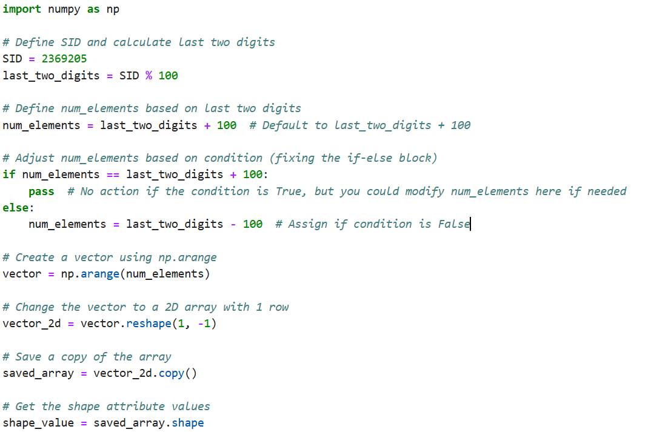

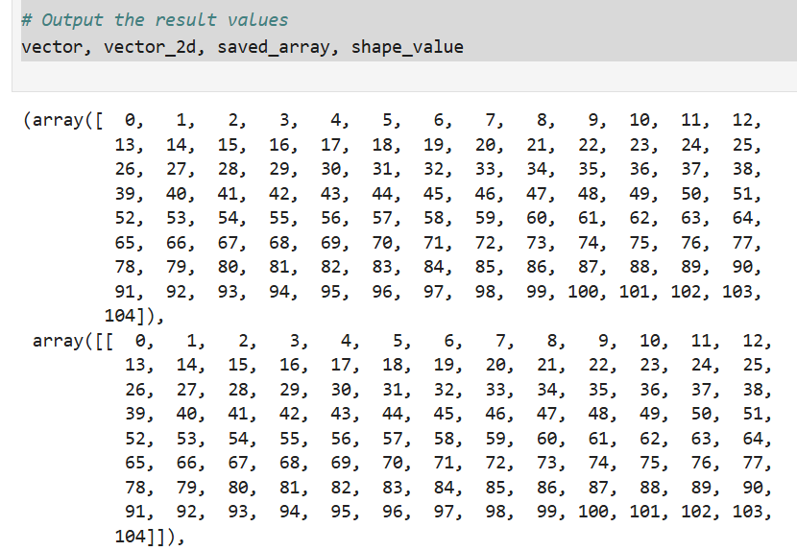

LAB 2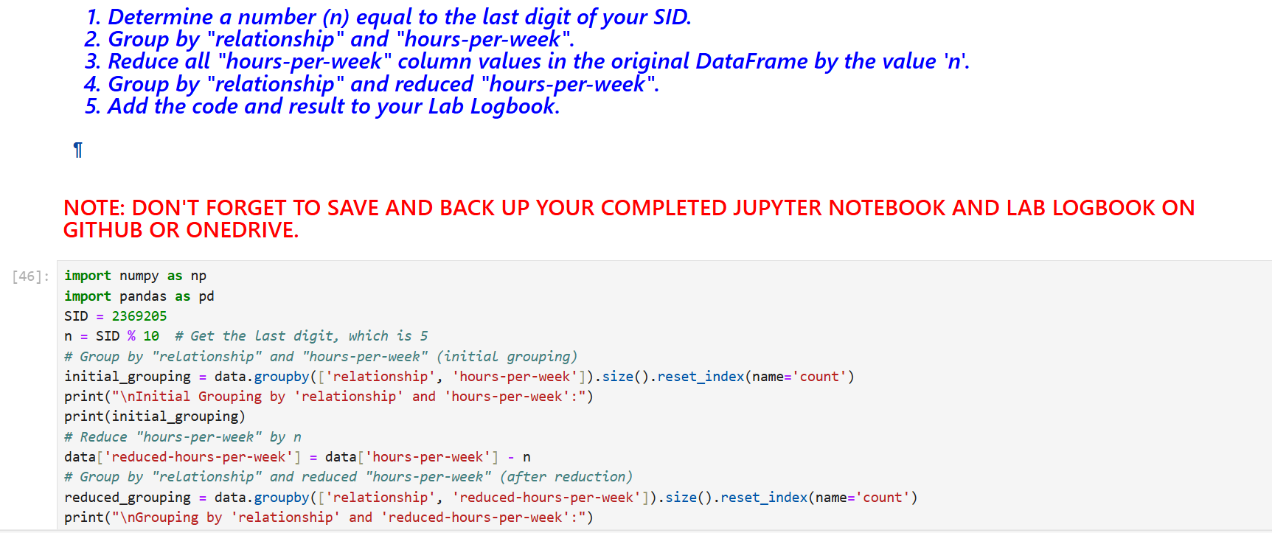

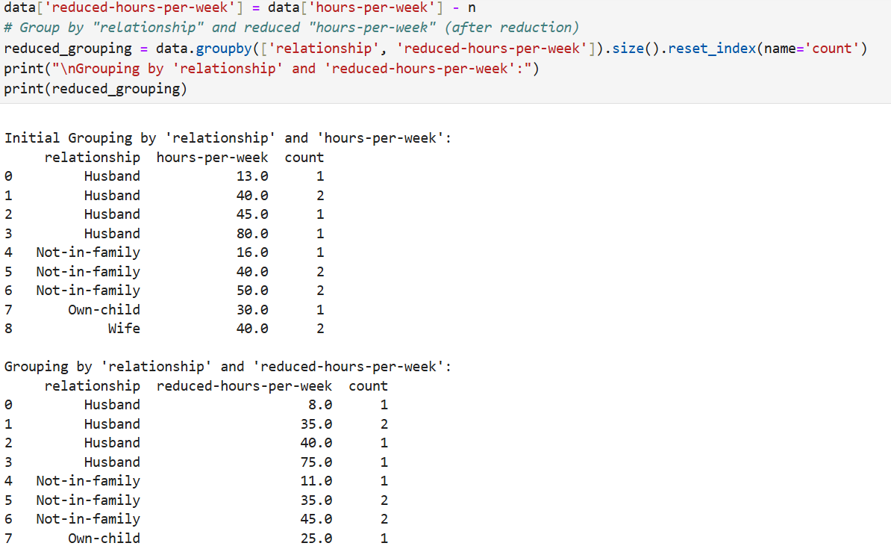

LAB 3:

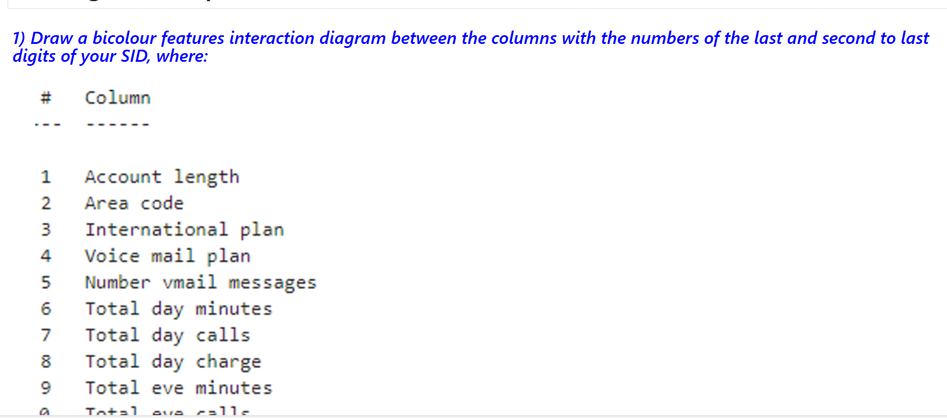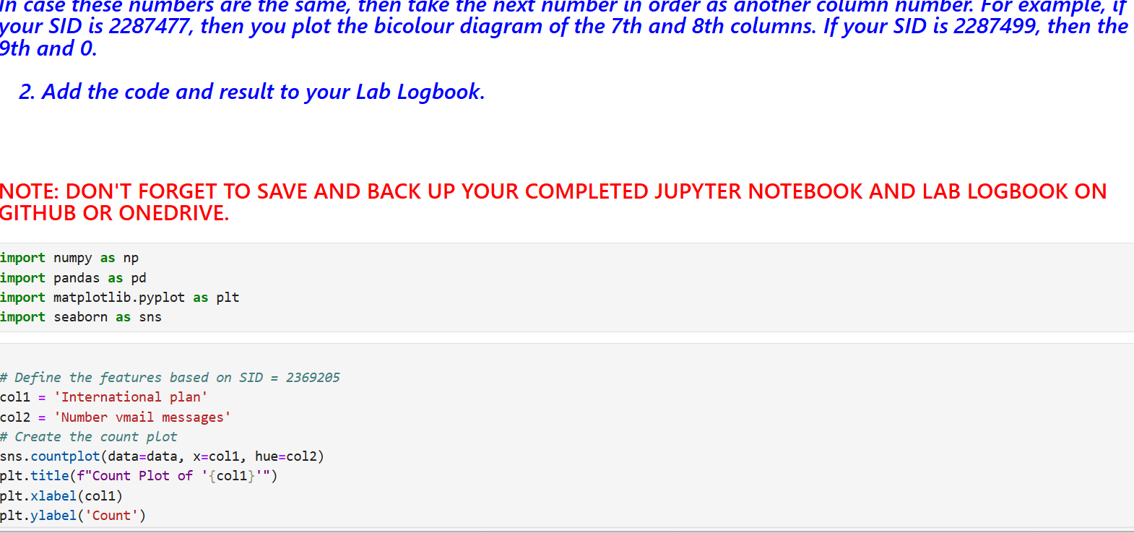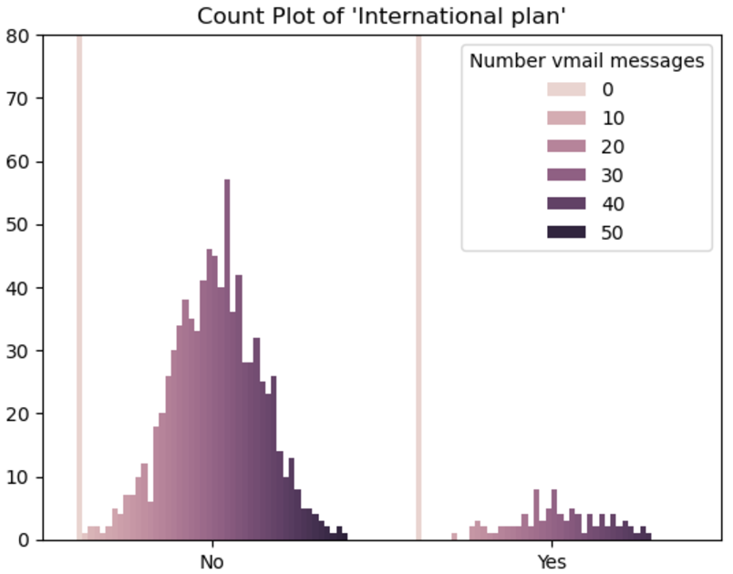

LAB 4: 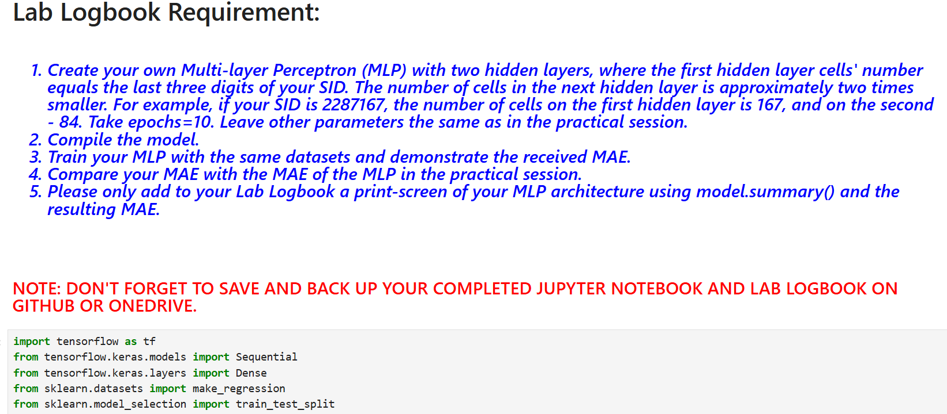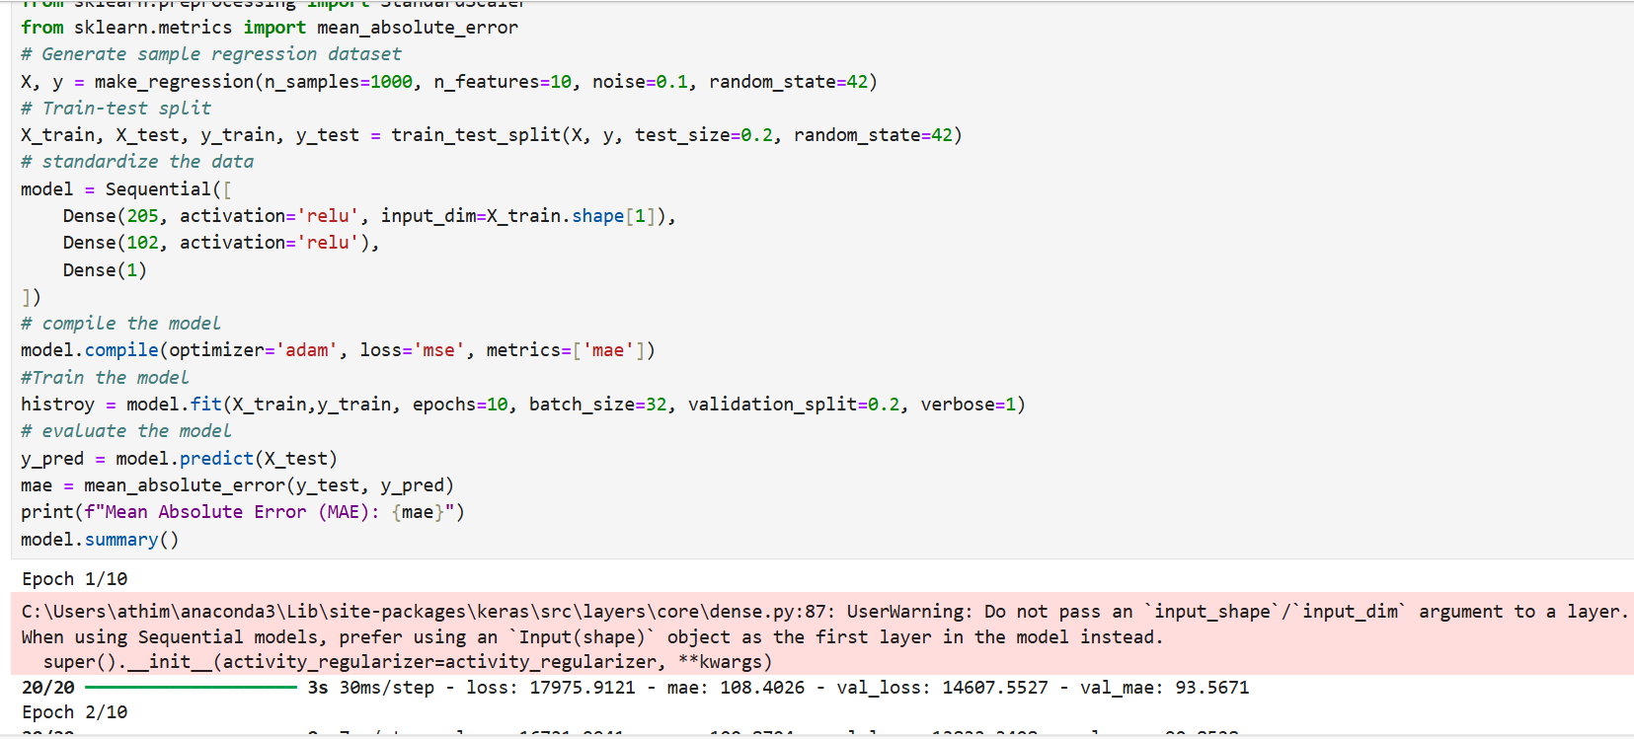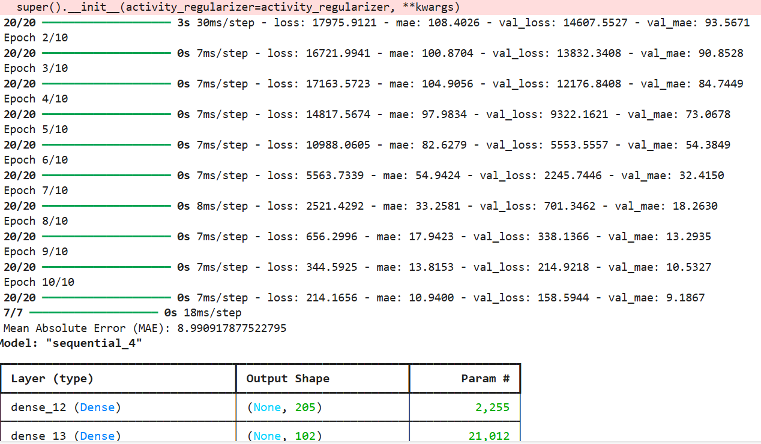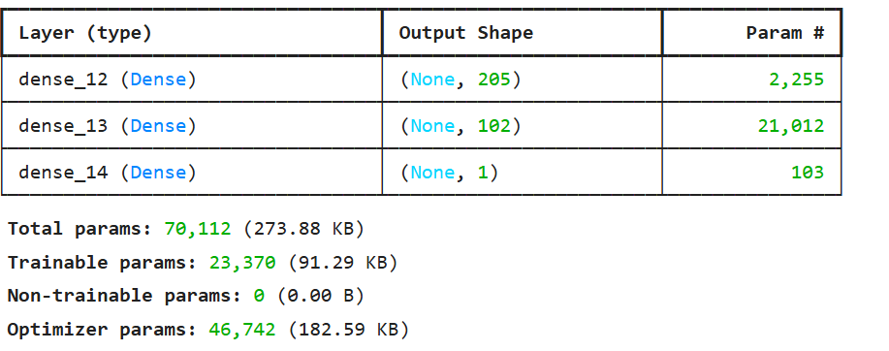

LAB 5: 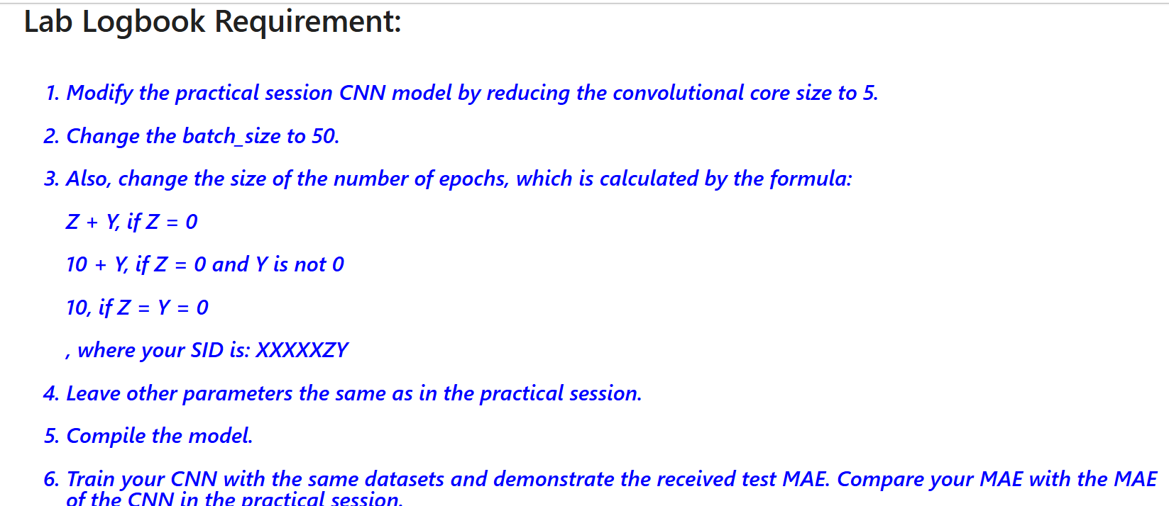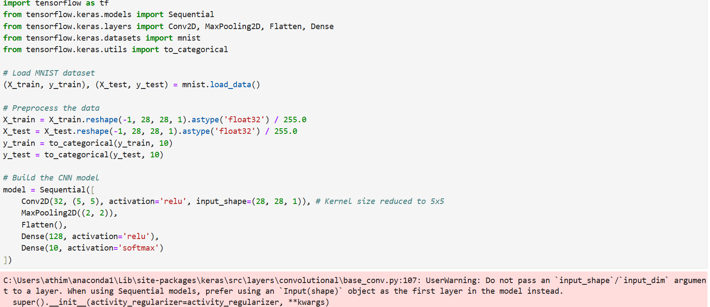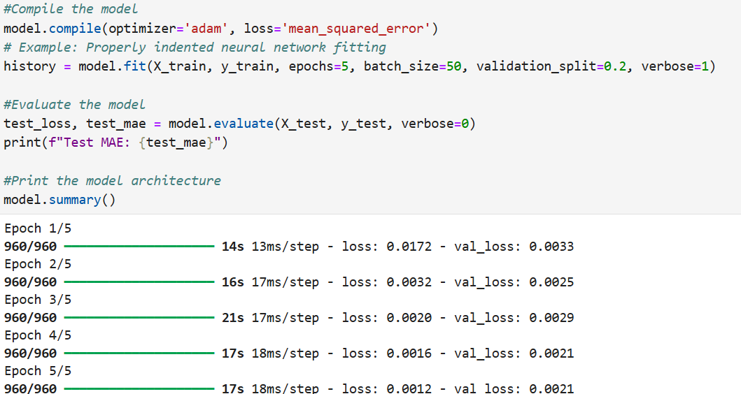

LAB 6: 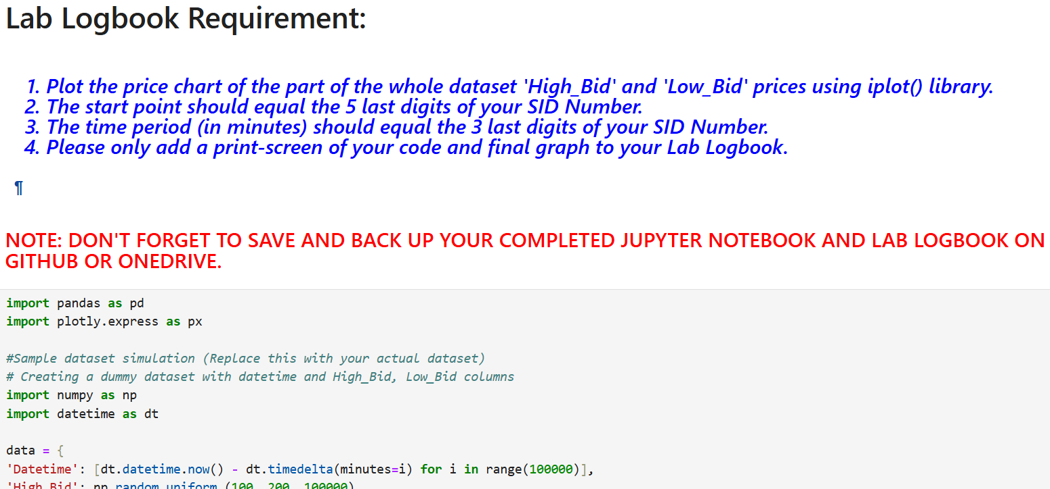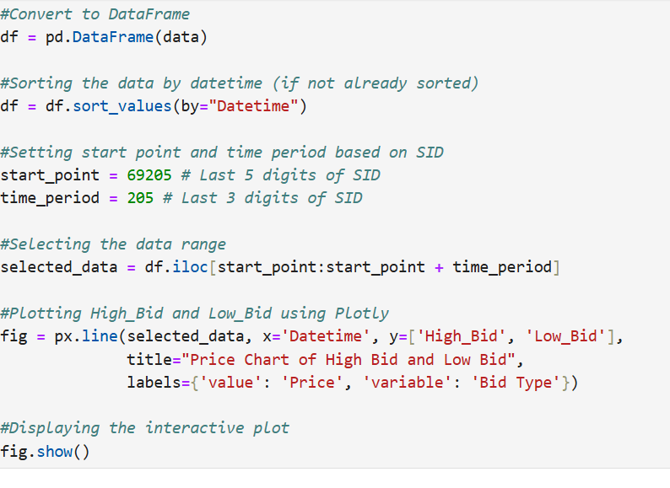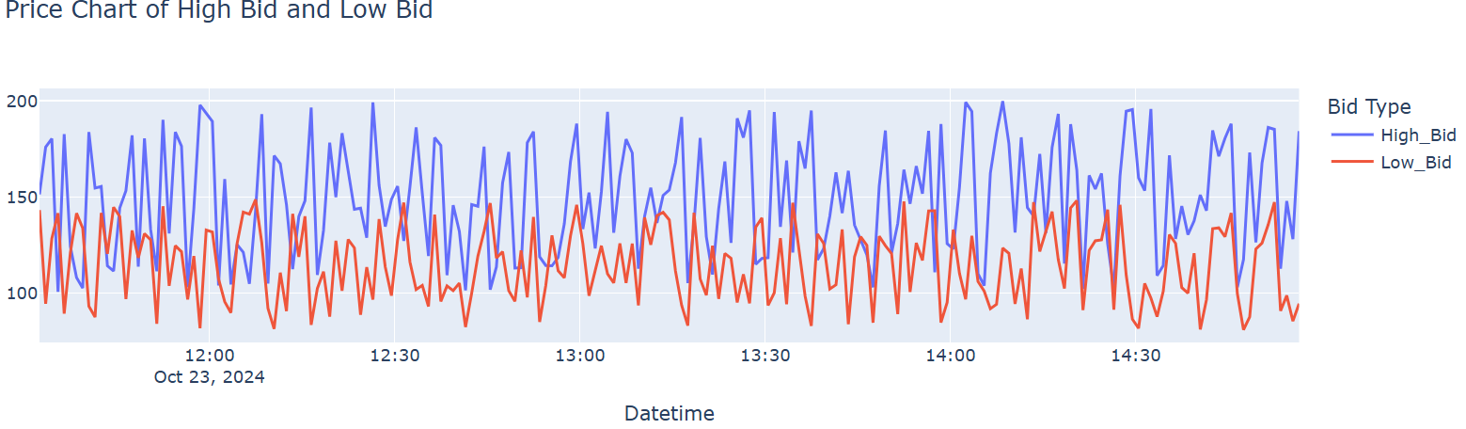

LAB 7: 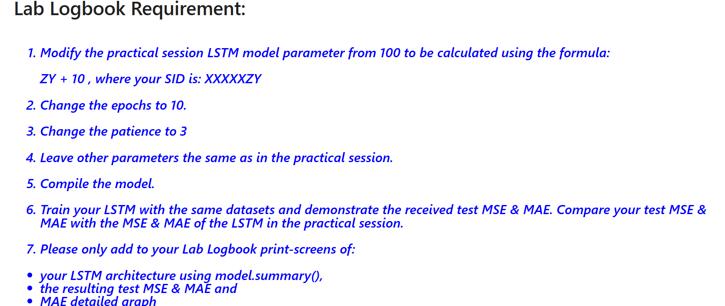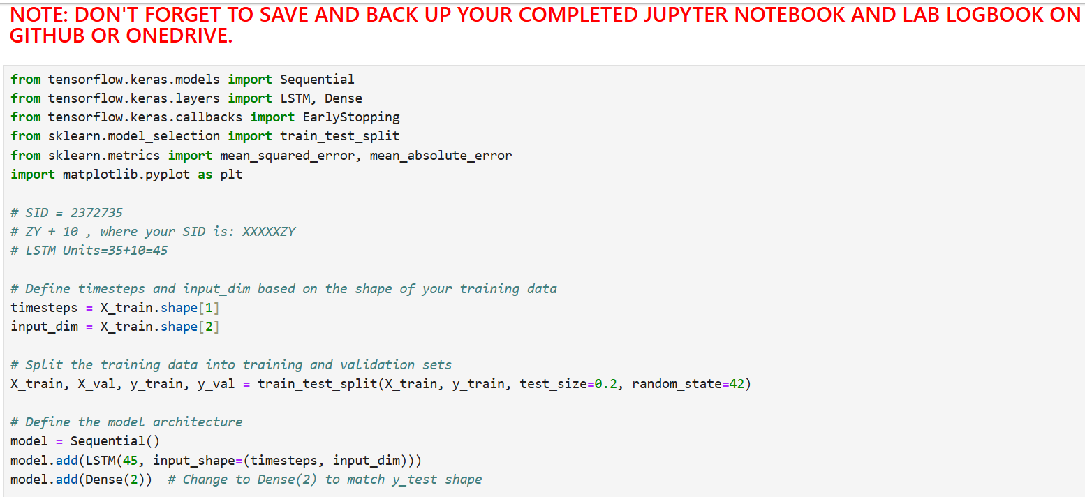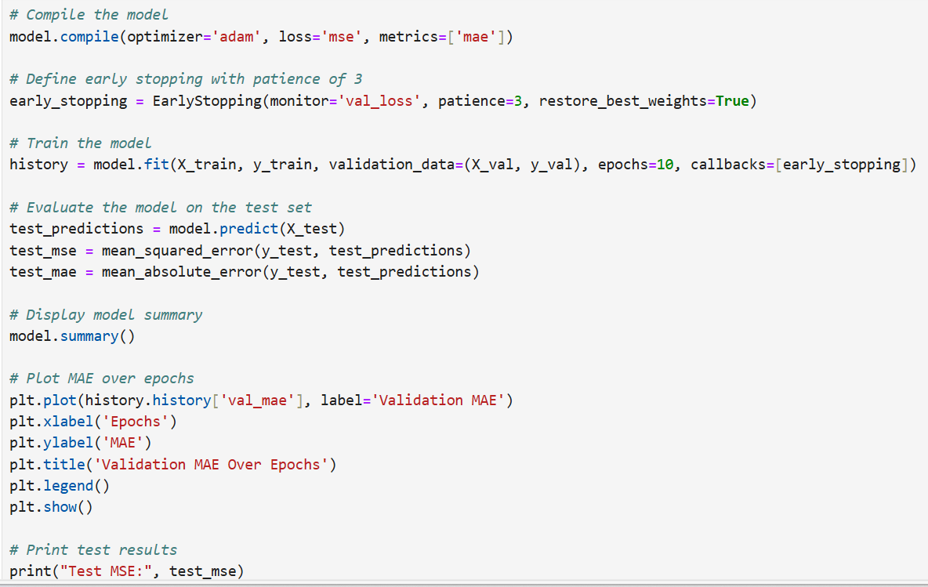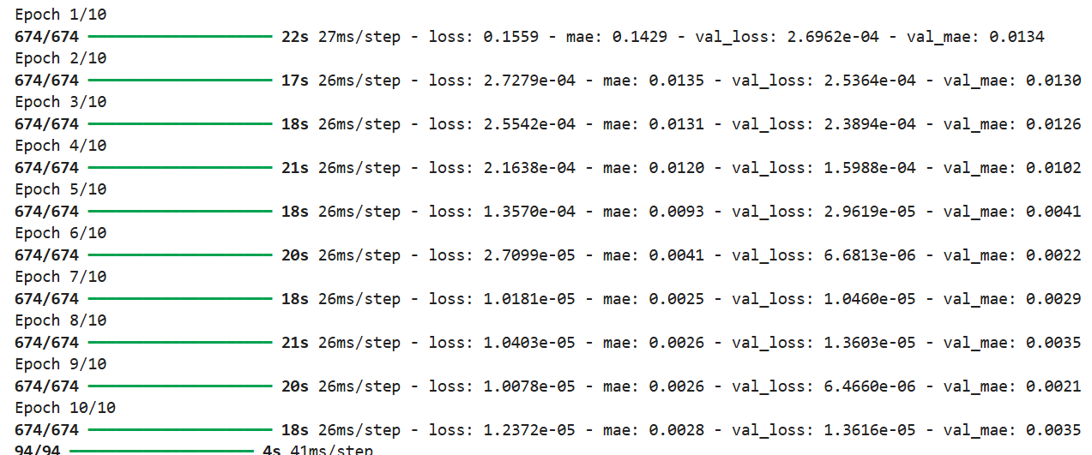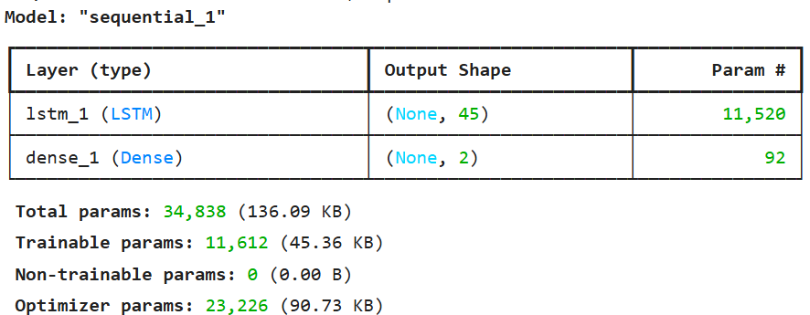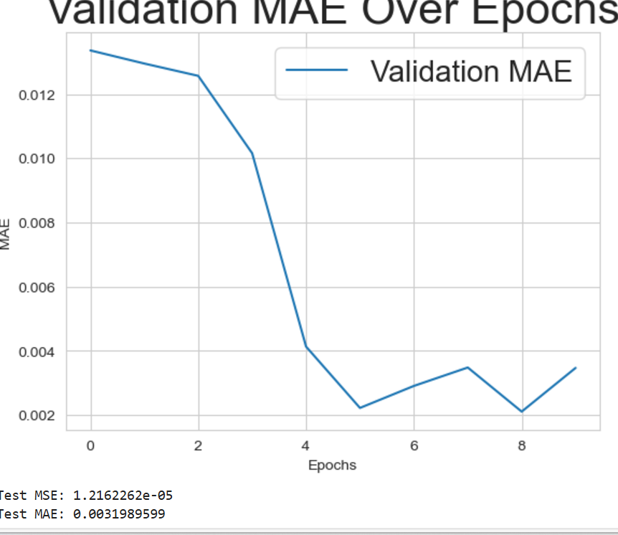

LAB 8: 